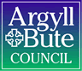

Standards and Quality Report 2024 - 2025

Inveraray and Furnace Primary Schools

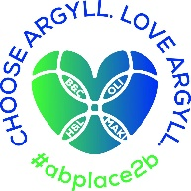


Context of the school
Including some or all of the following:
- basic school details (roll, class composition etc.)
- school vision, value and aims;
- local contextual issues;
- factors affecting progress (e.g. staffing changes/issues).

Inveraray Primary School and ELC and Furnace Primary School are joined under a Shared Headship. Since November 2024 Furnace Primary has been mothballed and children have been attending Inveraray Primary, hence the reason for the Standards and Quality report to cover both schools.
Inveraray Primary School
Inveraray Primary School is situated in the Royal Burgh of Inveraray on the shore of Loch Fyne. It is part of the Mid Argyll cluster of schools in Argyll and Bute. There is a strong tradition of quality Outdoor Learning being planned and implemented at Inveraray PS.
In session 2024/25 we had 18 children registered in our nursery and 68 children registered in Primary 1-7. We operated with three classes and ELC:
ELC with 18 children
P1/2 with 21 children
P3/4/5 with 24 children
P6/7 with 23 children
The school had 5% of children entitled to Free School Meals. Six children have English as an Additional Language. The SIMD demographic is:
3.2% Decile 3
96.8% Decile 6
Furnace Primary School – has been mothballed since November 2024
Furnace Primary is situated in the centre of the village of Furnace also on the shores of Loch Fyne, and is also part of the Mid-Argyll cluster of schools in Argyll and Bute. Furnace Primary School was mothballed in November 2024.
At the close of session 2023/24 we had four children registered at the school – 1 pupil in Primary 3, 1 pupil in P5 and 2 pupils in Primary 6.
All children attending Furnace PS were in SIMD Decile 6.
Furnace PS underwent a successful HMI inspection in November 2022.
Our schools aim to work closely with our communities and parents and to use our unique situation to enhance the children’s learning experiences.
We value kindness, perseverance, cooperation and enjoyment as key factors that influence success in school and life. We started a review of our curriculum having based our curriculum rationale previously using four lenses of looking forward, looking backward, looking inward and looking outward to support planning and provision of curriculum experiences which are relevant, coherent and challenging. We use the wider context of CfE and the context of our school, making best use of local strengths and preparing children to grow, learn and thrive as they grow and support each other.

Review of SIP | Priority 1
Attendance and Achievement
Progress and Impact:
We reached our target for almost all children in both schools this session, This was achieved by working closely with families and planning Nurture and Curriculum activities that were motivating for the children. We received our Silver Accreditation for Our Children Their Nurturing Education which is an indication of the quality and effort put into this work. We still have a small number of families who are taking their children out of school for a family holiday and the number of unauthorised absences has arisen as a result. For a very few children there is a pick and mix approach to coming to school and invariably, parents have either supported this or struggled with it. We have also worked in close partnership with The Exchange – we has strong support for the first term and a half, which did appear to help our young children but there were some consistency difficulties towards the end of term and we still have some children awaiting their sessions, which will be started in August 2026.
We have started to have progress and attainment professional discussions and tracking has clearly indicated where we apply interventions this session. Assessments completed before and after interventions for literacy and numeracy all show pupil progress for targeted children. Children made expected progress or exceeded expectations. We now need to embed tracking discussions and enable staff to use data for themselves to inform pupil progress with the Senior Leadership Team having an overview.
Boxall assessments with Nurture children showed excellent progress made, but there is still work to be done. Specific evidence can be accessed on the links below. Academic data has informed which children should have specific interventions and these have been planned and implemented by teaching staff. Nurture sessions have been expertly planned and implemented by our Pupil Support Teacher, who has also developed our Nurture space, alongside the children.
Learning targets have been set, shared with pupils and parents and are a focus for achievement. Through pupil surveys, almost all children have indicated that they know what their learning targets and what they need to get better at. Feedback from parents has been very limited with 16% return on parental questionnaires and limited returns from parental comments for report cards in the Summer Term, however feedback that we have received has been positive regarding pupil progress and support offered by the school. Attendance and contributions from parents at Parents evenings throughout the year was excellent.
Staff and children have also worked closely with the Local historical society associated with Inveraray Castle. P6-7 Children researched with local professionals what Inveraray was like during the War, reading first-hand accounts and also worked with a Drama specialist, funded by the Historical Society to write and perform a play about the residents and events during World War 2 locally. Children performed to a packed school and church hall over two evenings in November 2024 and feedback from the audience and parents was tremendous. Interest and motivation was such that the Local Historical Society offered an after school club for P6-7 – this is continuing to foster a real interest in history from first hand resources under the supervision of professionals locally. It is also having an impact on children’s learning motivation through attendance and production of work.
We conducted a review of our Curriculum rationale and this was ably pulled together by our P6-7 teacher who created a visual representation of the overall design of the school’s Curriculum. We also started to plan longer term themes for Core Subjects for each year group – this needs to be picked up and developed further in 2025-6 session.
Children completed SNSA’s and all children have made expected progress. Due to historical issues regarding staff understanding of levels, we have required support from central officers and data submitted into the local authority in June 2025 was correct. Further work in needed to ensure teaching staff are in line with what we view as a National Standard. Staff refer to the National benchmarks and a number of sources from the children’s work to make their judgements. Tracking and use of data to inform learning and teaching will be a focus for improvement in session 2025-6.
The PEF paper accompanying this paperwork also outlines on pupils and staff impact.
Next Steps:
Use of data in a different way (teachers taking the lead) in terms of analysis and PT and HT being part of this to inform learning and teaching
Further moderation activities for data and achievement of a level.
Curriculum development – creative approaches to social and expressive arts subjects as well as progression frameworks for Core subjects and STEM.
Interventions identified from data and knowledge of families and implemented in classes with Class teachers taking responsibility for delivery, in partnership with support staff.
It is our intention that that we will continue to work with Family Liaison Officers next session with identified families.
Self-evaluation activities will take place throughout the year rather than during one focused term.

Review of SIP | Priority 2
Achievement, Health and Wellbeing and Engagement
Progress and Impact:
We have developed the House system which has been linked to House points and all children report this is understood and successful. Children felt it improved behaviour and provided fun activities throughout the year. All Primary 6 children were given Sports Leaders training by our Active Schools Co-ordinator and will be providing further sessions on the playground for 2025-6.
Our Achievement Display Wall has been organised by class teachers and celebration of achievement assemblies which have been very well attended by parents and carers. This seeks to recognise achievement within school as well as wider achievement. We have also had almost full attendance and excellent feedback for termly class visits when parents/carers can work to support their child’s learning in the classroom. Our Nurture lead, also implemented a highly creative weekly Staff achievement and recognition award which was highlighted as a strength in our OCTNE award in June 2025 – staff have also appreciated this and evidence from PRD’s and staff attendance, it has contributed to an improved sense of wellbeing.
Displays within classes have been linked to RRS, and while displays in classrooms celebrate children’s work and support learning, our learning walk activities indicate that we still have significant work to do to ensure all display around the school is of a consistently good standard. This will be a focus for session 2025-6.
In February 2025, the school achieved our 10th Eco flag and we were awarded a special award from Education Scotland; we had a whole community celebration as so few schools nationally have received this many flags. This bid and its evaluation was led by Mrs Zuccarini and the Eco committee.
Staff, children and parents have been working very closely with The Exchange to ensure identified children get the professional counselling help they need to feel emotionally well for learning. Some children have made such progress that they have stopped the sessions and their attendance has improved and they have reported feeling more confident and have strategies in place to help them.
Our lead for Outdoor Learning has been planned, implemented and evaluated for Forest and Beach School sessions from ELC to Primary 7. This work has been led by our P1-2 teacher and supported by the Team of teachers, support staff and trained parents. This has also included working with local businesses considering sustainability and Estate Managers regarding management of the Estate including looking after wildlife (managing deer population), making venison burgers and installing and monitoring bird boxes. Attendance has gone up as a result of these re-focussed sessions. Almost all teaching staff and parental volunteers also attended First Aid sessions over a weekend in March 2025, which demonstrates a clear commitment.
We have recorded 4 incidences of bullying throughout the year and also contacted parents regarding misogynistic behaviour exhibited by P6-7 boys towards female pupils and members of staff. We worked closely with parents in order to see an improvement in behaviour and attitudes and there was no recorded incidents from May-June 2025. Our PT attended national training relating to Bullying and Gender Awareness and will be co-ordinating how best to teach appropriate responses and expectations that take this behaviour into account.
The school achieved Silver accreditation for RRS in May 2025, ably led by our PT and Nurture lead and we have a Gold Plan in place. Nurture training and restorative practice was provided to all staff in March 2025 and strategies implemented. Staff questionnaires indicated a distinct improvement in attitudes and improvements made throughout the year.
All children from Primary 1 attended Yoga sessions, led by a qualified instructor who also happens to be a parent in the Autumn Term – she was supported by teaching staff and the children reported that they enjoyed the sessions.
Drumming lessons were undertaken under a qualified instructor from May until June with P4-7 which were fantastic and very motivating for staff and pupils. Pupils performed brilliantly on the playground for parents and friends of the school in June 2025.
All children have engaged in two sessions with professionals from Heart Start focussing on First Aid and reports from parents and pupils were extremely positive.
All P6-7 pupils completed the Bikeability programme in June 2025. Members from teaching staff, ELC and parents received training to deliver the programme and we also received support to maintain the children’s bikes and to provide suitable road-worthy bikes for the session from Active Schools. Parents, children and the local community have all expressed their appreciation of this work as the children spend a lot of time on their bikes during the summer around the village and there are a lot of tourists around, so this has been viewed as a vital lifelong skill which will also impact on pupil mental and physical wellbeing.
All children from P3-7 took part and supported The Wizard of Oz during the Summer Term 2025. There was a fantastic buzz around the school and there was a maximum capacity audience for 3 performances. Our P3-4 teacher re-wrote the play and we had the support of local musicians which also helped the children to ‘up their game’. We raised almost £350 for school funds and feedback was super. Class teachers for P3-P7 led the production and were brilliantly supported by teaching and support staff. Children designed tickets, posters and a new backdrop for the performances, so there was a real sense of ownership and children and staff reported an increase in confidence and positive behaviour during June 2025 which we felt also impacted on SNSA’s in terms of results.
In June 2025, the office arranged and the Parent Council paid for a P6-7 school trip to Glasgow. The children completed activities at Kelvingrove Museum and Art Gallery, they visited The Riverside Museum, had a fantastic time playing at a huge play park at Glasgow Green with an evening visit to The Kings Theatre for a performance of The Lion, The Witch and The Wardrobe. Again, feedback was extremely positive and for some children this was not only a fantastic experience, but it widened their horizons. Parent Council members drove community minibuses for the day, which saved us £900.
The Relationships and Health Programme has been shared with parents and implemented across the school – we have also been supported by the local community nurse in a number of sexual health sessions, as appropriate.
The pupils organised a school Bingo night as a fundraiser. They requested prizes from local businesses and co-ordinated the evening. They also wrote thank you letters for the donations and raised over £450.
Our Primary 7 pupils had opportunities for visits and support from LJC during the Summer Term. We need to improve pastoral support and sharing of attainment information for Session 2025-6.
Our Nurture sessions led by the Nurture lead has been a real success story this year, with all targeted pupils showing improvement in attainment and Boxall profiles (please see section above for further details). We hope to continue with the principles of Nurture across the school from the classroom and continue utilise support staff to support Nurture.
Breakfast Club remains as popular as ever, with staff and parental support and children feeding back that it is a really positive start to the day.

Next Steps:
Display policy and practice
Continue to develop Positive relationships and behaviour policy in partnership with pupils and all parents. Bullying and Gender awareness sessions to be delivered by PT (KZ).
Work on RRS Gold plan actions.
Continue to work with The Exchange and other agencies to support children, as appropriate.
Collaborate in MAKI plan for continued improvement in Transition and build on Profession learning in a collaborative with other schools.

Review of SIP | Priority 3
Developing leadership at all levels
Progress and Impact:
The children have been working closely with our P6-7 teacher as the Pupil Council and as a result of this the House System was re-structured and implemented successfully. The children have also designed games for the playground and been at the Centre of our Eco Schools and RRS Award activities and evaluation. This has improved behaviour and increased pupil communication skills.
The PT (KZ) continues to take the lead regarding Pupil Support across the school and works closely with our Nurture lead. Child’s Plans written by PT (KZ) and she has worked closely with parents and other agencies and show children’s progress over the session
Our P6-7 teacher started a RRS steering group and much of the work completed contributed to our Silver Accreditation. From pupil surveys in June 2025, children indicated that they are heard and listened to and their ideas are valued. Our P1-2 class teacher has planned and led Outdoor Learning successfully this year and P3-5 teacher continues to lead for our music and STEM programme.
Teaching staff completed a programme that focussed on developing pedagogy, with the support of Educational Consultant Iain White. Please see separate report on the progress made as this had a considerable impact on staff professional learning as well as pupil learning. The programme included professional reading, a focus on developing an area of pedagogy, visits to other schools/settings, lesson observations and coaching. Staff also completed Practitioner Enquiry sessions with The Open University and were able to record impact on their PU with GTCS. This ensures the children receive the best quality learning and teaching experiences that can be evidenced in lesson observations and other self-evaluation activities.
One member of staff, Valery Munro, has continued to study a learning and teaching module worth 60 credits with The Open University and another, Cara Blyth, completed her teaching degree with us through The OU and has secured a place on the Probationers PGDE course with UHI for August 2025. This has helped to build capacity within the school and across education and also ensures that the support the children receive is of an excellent quality due them working with qualified staff who are studying current theory. This is demonstrated through observations on how support staff are used and their quality interactions they have with learners and their own professional reflections.
Miss Bowers started the Argyll and Bute Middle Leadership programme and is using her work with us as a basis for her reading and writing in reflection of her developing leadership skills. Our school production Team worked brilliantly together to provide the children with an incredible learning experience in performing The Wizard of Oz. The children sang and performed incredibly well and could identify the skills they had developed.
The Open University Module 103 Learning and Teaching in the Primary School that was filmed here in September 2023 went live to students internationally in October 2024. Over 2000 students are now using the lesson observations, learners experiences and pupil contributions from Inveraray PS to study best practice in learning and teaching. This is an opportunity that could be utilised by the LA for staff development as invariably, the course is fully funded by the Scottish Government.

Next Steps:
Continue to undertake actions that ensure Pupil Voice is developed in an authentic way.
Continue with professional reading for staff and contribute as part of MAKI cluster professional reading. Demonstrate impact on pupil learning as a result.
Support members of staff who are completing LA programmes and National Professional Learning Programmes.
Our PT (AC) will take a strategic lead in ELC for 2025-6. Mrs Clarke (HT) will continue to have an overview.
Show Education Manager the E103 OU Materials with a view to sharing more widely across the authority. Support parents and staff who have continued to enrol with the module and offer placements as appropriate to students, in line with the LA volunteer policy.
Ensure our practice and policy for professional leaning is in line with the LA approach and policy.

Review of SIP | ELC Priority

Progress and Impact:
Staff and management have reviewed 7 policies and implemented appropriate practice. Staff are aware of guidelines and policies in place and this can be demonstrated in their everyday practice. All staff also visited Colgrain Nursery and Campbeltown Nursery to look and practice, planning and the environment. Plans were discussed on how we could develop our environment further but there has been difficultly in funding this. We want to continue to focus on our environment developments next session 2025-6. We have identified key areas of development such as planning, development of the environment and assessment that we wish to develop as a result of the visits. We also reflected as a team as part of our self-evaluation work on the quality of the children’s experiences and the learning space and have highlighted future training for reviewing the quality of our observations as a result of these visits.
PRD’s were completed April – May 2025 and staff have been booking appropriate CLPL programmes to attend to meet the needs of staff and the Unit. Whole staff training in partnership with Ardrishaig Primary with a focus on quality learning experiences will take place in August 2025, with pick up again in February 2026
Transition arrangements have been implemented for our new P1 children with P6 buddies, planned activities and also daily experiences that gradually introduce children to the next stage of their education. Data regarding children’s milestones demonstrated progress and was also shared with teaching staff during the transition period.

Next Steps:
Our PT (AC) will take a strategic lead with ELC, which will also have an overview from Mrs Clarke (HT) as the Manager.
Further training from LA in August and February will be undertaken in relation to good learning and teaching and developing the environment, in partnership with Ardrishaig PS. There will also be planned visits to respective settings to collaborate on this work.
Focus on improvement for the learning environment, planning and assessment and reviewing our work on quality observations.
Training will also be offered to members of staff regarding working with children with neurodivergence, communication and quality self-evaluation.

Attainment Data – Inveraray Primary
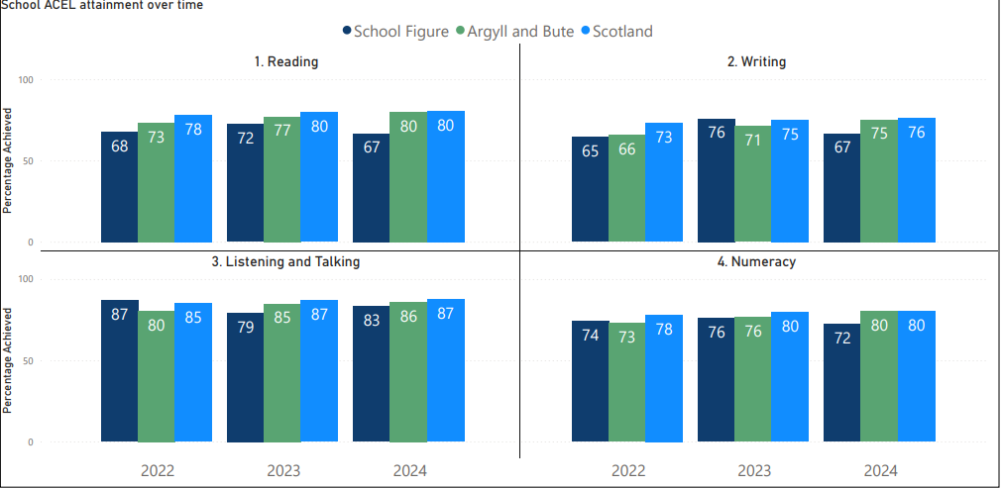
Attainment Data – Furnace Primary
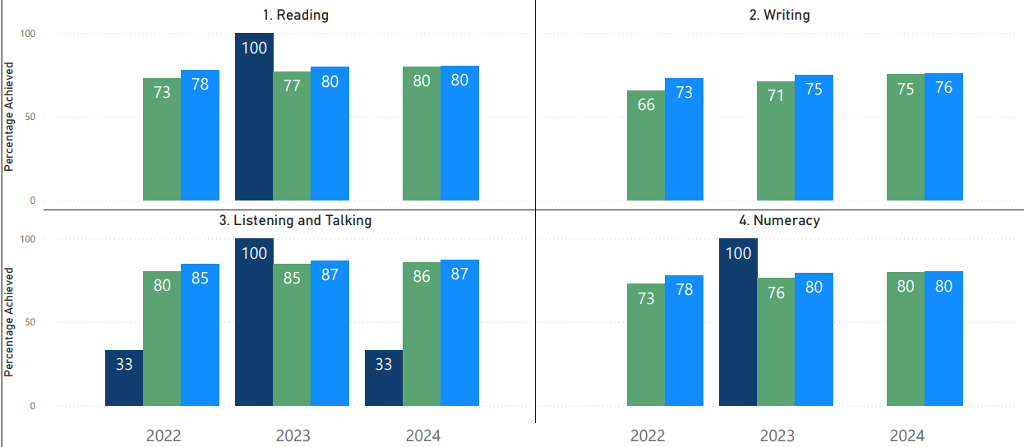

Wider achievements
- What opportunities for wider achievement were offered?
- What systems are in place to track and monitor participation?
- How have you addressed any gaps in participation?
All children from P3-7 had Rugby sessions led by Active Schools and Andrew Guthrie, a local qualified coach. This made a welcome change for some children instead of football and we hope to continue into next year.
Mrs Maclugash offered after school Badminton sessions during the Spring Term to P6-7. Children opted into this if they were interested in coming along and almost all attended. All P6-7 children also took part in the inter-schools badminton competition in March 2025.
Shinty Club after school for P3-7 children remains a popular and busy activity from November – April 2025. This is organised by local qualified coaches and the selected Teams have represented the village three times this year in National Finals in Fort William.
Our P6-7 organised our fundraising Bingo night. Children promoted the evening locally, arranged the room, resources and monies and called the numbers on the night. They all approached local businesses for prizes and received some incredible contributions. The children raised over £600 which went towards their summer trip to Glasgow in June 2025. The children wrote letters to thank the businesses for their support.
P3 children had 5 weeks of an extra –curricular Gymnastics Club in May-June offered by Mrs Clarke. This was open to all children who were interested and the children were also supported by P6-7 children who have completed sessions with Mrs Clarke in previous years. Feedback was extremely positive.
Pete Clarke came in on a weekly basis to offer Gardening Club to P6-7 children who were interested. The children have successfully grown cabbage, potatoes, green beans and carrots. They have supplied the kitchen and also taken produce home.
All P3-7 children took part in Christmas singing in village – we sang at The George for residents of Chalmers Court (and Santa visited the children here), and at the Co-op. All children from Pre-5 to P7 attended a Christmas Party at Inveraray Castle, hosted by The Duke and Duchess of Argyll.
Our Wider Achievement board is groaning with content of photos and comments from children taking part in dancing, music activities and sporting achievements that have been completed out of school. We have two dancers who have won numerous trophies at national level and also been covered on the television for their efforts.
Our pipers and representatives from P7 attended local village Remembrance Services in November – something they found profoundly moving.
Primary 6-7 children took part in an inter-school Burns recital in January 2025, supported by the local Burns Society.
Lochgoilhead Fiddle workshop also offered P4-7 children sessions for learning the fiddle in May 2025.
Glasgow Science Museum visited the school to offer enrichment exploration days twice over the session and the classes were buzzing with enthusiasm.
Our themed Scottish evening in January 2025 saw all families and the local community celebrate Scottish culture through dance, poetry and song. This is an extremely popular evening and one that all children love.
We held a Grounds day in September 2024 with the Parent Council to tidy up some of our environment ready for the winter.
In August 2024 we took our young pipers through to the World Piping Championships in Glasgow for the day. They were inspired by the standard of pipe bands and were over the moon to be able to support Inveraray and District Pipe Band when they won the competition.

Pupil Equity Funding
Summarise progress and next steps in relation to pupil equity funding

Progress and Impact:
Our targeted children working with Hannah MacLeod and with Class Teachers completing a programme with Iain White have all made measured progress.
Breakfast Club remains extremely popular. This is supported by members of staff, the Coop and parents. Children and families report back mid term and at the end of the session that it has a good impact on their health and wellbeing and provides a positive start to the day.
For further evaluation see attached PEF report

