Parent Council HT Report November 2025
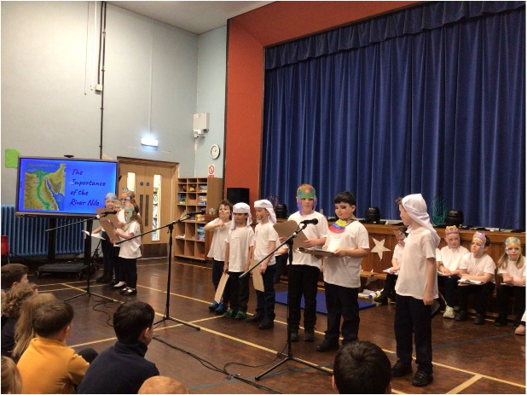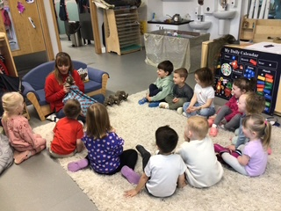
Staffing and ASN review
My thanks to staff, parents and carers for their incredible support since the beginning of term. We continue to have some members of staff off on long term sick leave as well as staff absence through illness on a weekly basis.
We were notified on Monday 24th November that we will be receiving support from Miss Bell once a week as a Pupil Support Teacher for ASN. We are extremely grateful to the Parent Council for their support in ensuring that we have all the tools we need to effectively support all of our children. All staff should be commended for the continued support and commitment to ensuring all children’s needs are met. I completed classroom observations throughout September and have been teaching in all classes and have been impressed with overall progress and the structured and focussed approach to learning and teaching adopted at the start of the year. Support staff also continue to go above and beyond in teaching our children – many come in during their own time and have also attended specific training sessions on their day off.
Volunteers have also been central to ensuring the learning and teaching standards are maintained. Hannah Sharpless, Valery Munro, Valery Kirkhope and Erin Naisby have all started and work hard in supporting our teachers and children. We have had enquiries from some other local retired teachers that we are following up. We are also supporting another two OU students in their study of E103, one of whom is a parent and another who is a former pupil.
Breakfast Club continues to be well attended and supported. Our thanks to our volunteers and kitchen staff for their help in delivering this.
Workload remains a national issue and teachers have been balloted on strike action in the coming year.

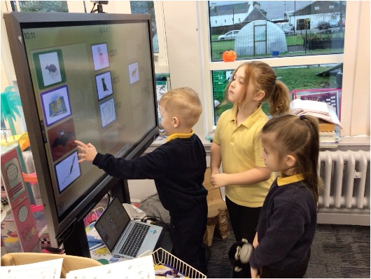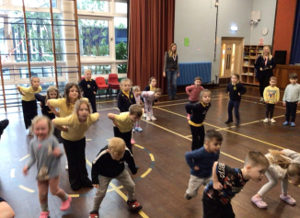

Quality and Standards Report and School Improvement Plan
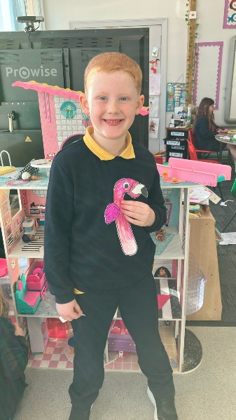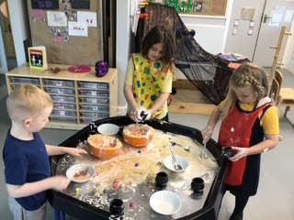
School Improvement Plan
We have set academic targets for all children in both schools this session and these were shared with parents earlier this term.
Unauthorised absences are accounted for by a small number of families who are taking their children out of school for a family holiday or in relation to pupil behaviour or mental health. Unfortunately, although there has been some improvement since last session, for a very few children there is a pick and mix approach to coming to school and invariably, parents have either supported this or struggled with it. We continue to try to work with families in supporting their child to come into school. Some families are working with Family Liaison Officers and have also worked in close partnership with The Exchange and would want to continue to ensure our families have specialist support, as required.
We have started to have attainment professional discussions and tracking has clearly indicated where we apply interventions for this session. We now need to embed tracking discussions and enable staff to use data for themselves to inform pupil progress with Kyrsti Zuccarini and Sandra Clarke having an overview. My thanks to Mrs Zuccarini for her incredible commitment in Pupil Support, I simply do not know what I would do without her.
Staff have reviewed how they are planning for the long term and the creativity in the Curriculum has been marked since August. This includes our topic-based approach, teaching of PE and art in particular. Primary 4-7 children have enjoyed rugby sessions with Active Schools this term and P3-4 have done extremely well at Gymnastics Club after school, with Kayla Wilson. We have also reviewed our display policy and been well supported by Claire McNichol and Alanna Bell to help improve the physical environment but there is still much to do. I was really impressed by P3-4 children offering the assembly last week in relation to everything they have learned about Egypt. This was from a springboard of support from the Parent Council to take the children to the Tutankhamen exhibition in Glasgow last term which made the learning really come to life.

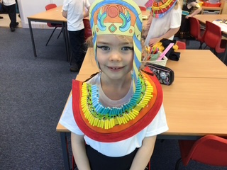
All teaching staff completed moderation activities with all schools in MAKI in relation to good quality feedback to pupils – we did professional reading, shared good practice and highlighted some aspects we want to concentrate on between now and February, which is when all teachers will meet again. Further training for Early Years staff have included Eco focus, importance of play and supporting neurodiverse students. Mrs Zuccarini has deliver Bullying and Gender awareness training for teachers across the authority. Some P6-7 children represented the school at the community Remembrance at the cenotaph on Sunday 9th November.
We have been implementing and following actions with our draft Positive Relationships and Behaviour Policy. We have ongoing issues with some pupils but have seen improvement in recent weeks and continuing to work with other agencies and families to ensure our expectations are adhered to.
The kitchen treated the children to some Venison spaghetti and lasagne and feedback was extremely positive overall!
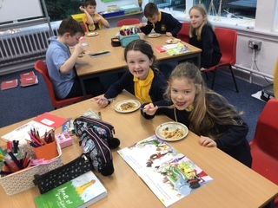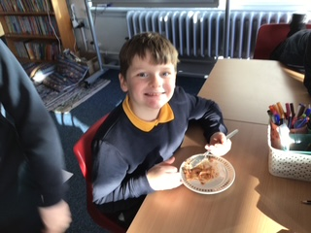
Pupils have also benefitted from full day visits from Glasgow Science Centre and Glasgow Music company – the place was buzzing! The children also enjoyed the Halloween Disco – some brilliant costumes and grateful thanks to the Parent Council for organising.

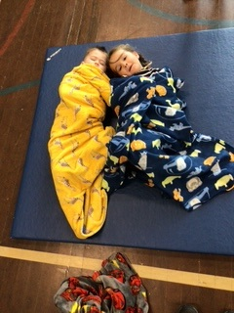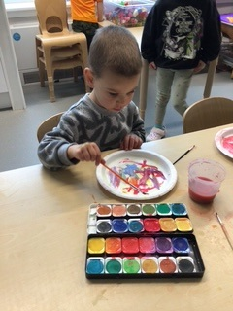

We are very much looking forward to the Castle Party in December. Her Grace, Duchess of Argyll popped into the school to discuss arrangements – children from the gardening club gave her some prize winning onions. The party will be for Nursery – Primary 4 children and we are grateful to the Duke and Duchess and their Team for their generosity. We are taking our P5-7 children to Dunoon on the same day to the cinema – again, the children are looking forward to a fun day. This is one of many events planned over the festive period.
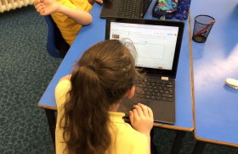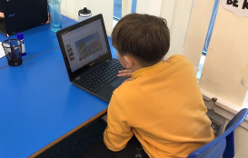
In February 2025, the school achieved our 10th Eco flag and we were awarded a special award from Education Scotland; I am in the process of working with Rachel Binnie, Education Manager to pull together an authority website for Outdoor learning and re-writing authority policy on school activities outside of school.
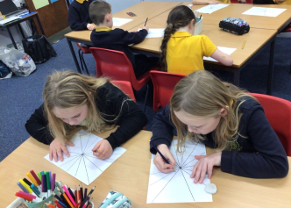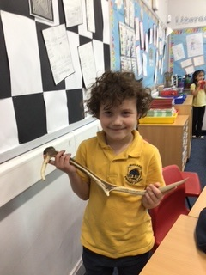

Our thanks to parents and carers for their time and attention in ensuring children are completing their homework – the new approach appears to be motivating the children and we had an impressive sharing session before October and it was mind blowing the quality of the work produced from families. We will be reviewing the policy and practice at the end of this session.
We have developed the House system which has been linked to House points and all children report this is understood and successful. All Primary 6 children were given Sports Leaders training by our Active Schools Co-ordinator. Playground toys and games have reduced the number of incidents staff are dealing with on a day to day basis.
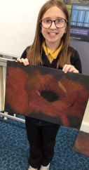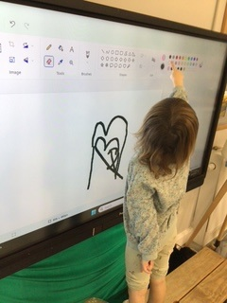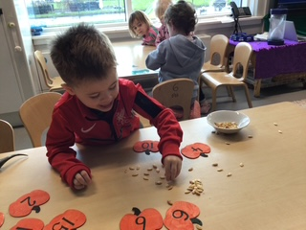
Displays within classes have been linked to RRS, and while displays in classrooms celebrate children’s work and support learning, our learning walk activities indicate that we still have significant work to do to ensure all display around the school is of a consistently good standard.

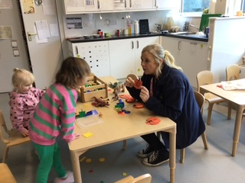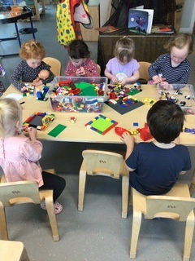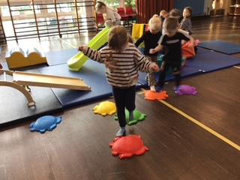
We have been fortunate to make links with Siemens BAM who are working locally and we are planning a number of projects with them, depending on some being cleared by LA. They provided every child with a pumpkin to decorate in October. They have offered to provide Christmas dinner to those families who need it over the festive period, they are providing us with Co-op vouchers for Breakfast Club food, some outside gloves for the Nursery children, new waterproofs for every child and support in tidying up the grounds for spring. They are also looking at providing us with a building that will replace the peace building – I am working to get permissions for this from LA. This kind of support is incredible and makes a difference to our families and the school itself.
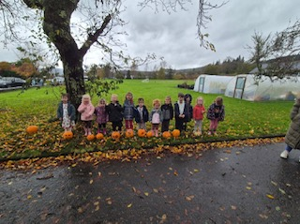

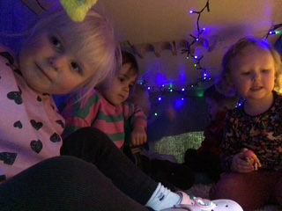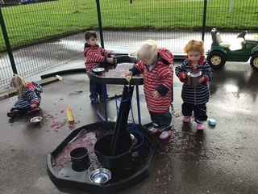
Our Primary 7 pupils will have up coming opportunities for visits and support from LJC during the Spring Term.
The Open University Module 103 Learning and Teaching in the Primary School that was filmed here in September 2023 went live to students internationally in October 2024. Over 3000 students are now using the lesson observations, learners experiences and pupil contributions from Inveraray PS to study best practice in learning and teaching. I have asked Simone MacAdam if we can discuss how this can be further supported across the authority in terms of opportunities for capacity building.
ELC
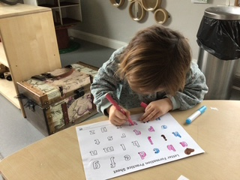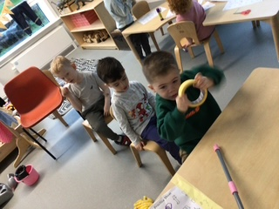

Whole staff training in partnership with Ardrishaig Primary with a focus on quality learning experiences will took place in August 2025, with pick up again in February 2026
Transition arrangements have been started for our new P1 children with P7 buddies, planned activities and also daily experiences that gradually introduce children to the next stage of their education.
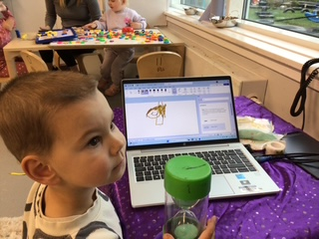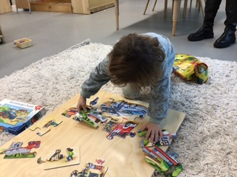
Further Wider achievement
Shinty Club after school for P3-7 children remains a popular and busy activity from November – April 2025. This is organised by local qualified coaches and supported by teaching and support members of staff.
Pete Clarke oversaw the children have successfully harvesting their grown cabbage, potatoes, green beans and carrots. They have supplied the kitchen and also taken produce home. Children won the Onion Cub at the Strachur Flower Show in August.
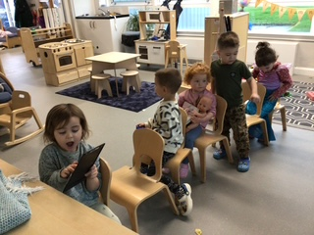
Next Steps:
Focus on Attainment and Achievement, complete ASN review.
Developing Curriculum planning and implementation
Display policy and practice
Approve Positive relationships and behaviour policy in partnership with pupils and all parents. Bullying and Gender awareness sessions to be delivered by Mrs Zuccarini.
Work on RRS Gold plan actions.
Continue to work with The Exchange and other agencies to support children, as appropriate.
Collaborate in MAKI plan for continued moderation.
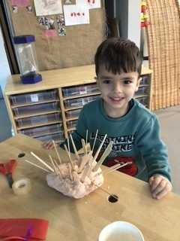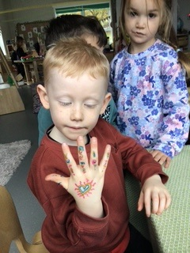
My thanks to Martin, David and Jaimmy for their support this year, it has been a challenging term and they have been right beside me and been constructive in making sure we do our best for the children. I am fortunate with the Team we have here and that the local community give such a lot. We know we do not always get things right but appreciate that families will come in and work with us to sort things out for children. We love working with your children and continue to work hard to make sure they are making the expected progress with what we have.
Sandra Clarke November 2025

